A Dual Wildlife Trading Model

(draft)

1. **Introduction**

* Unsustainable exploitation of wildlife is a significant concern for biodiversity conservation
* Policies at the local, national and international level have been implemented to reduce unsustainable use and trade
* However, restrictions on natural resource use (such as sanitary, conservation, quotas) can create dual trading of legal/illegal products because of maintained demand that is not met by legal products alone
* There have been advances in understanding how restrictions affect natural resource users, on one end, and markets on the other.
* However, research on how restrictions affect traders has been mostly conceptual with little data
* Traders connect markets and resource users, ultimately influencing how natural resources are used and managed.
* Therefore, understanding how restriction affect traders and dual trading dynamics is critical to halt the unsustainable use of natural resources.
* Understanding trading dynamics in dual markets is complicated because, usually, only legal data is available
* Simulation models can aid in understanding traders’ economic incentives for trading legal or illegal products (or a mix of both). These models can, therefore, help to elucidate overall legal/illegal trading dynamics in a system
* Moreover, trading is in itself a complex phenomenon, affected by ecological, economic and social factors that are far from static
* As such, it is critical for simulation models to consider intertemporal variability in the extrinsic or intrinsic factors that affect traders’ economic incentives.
* Here, we propose a generic dynamic simulation model to assess the economic factors that affect the decision to trade legal or illegal in natural resources
* The model can be adapted to a broad range of natural resource contexts and allows to include stages with different trading strategies through time, to reflect on market/management/ecological variability
* The model can be used to predict the effect of restrictions, estimate amounts of dual traded products and help to answer 'what if' type policy questions to reduce illegal trading at specific stages
* We show the utility of the approach by providing a small-scale fishery case study where we applied the model. Results from the case study provide relevant management insights into the dual trading dynamics of the small-scale fishery
* Halting unsustainable use of natural resources requires better understanding trading dynamics. Simulation models can aid in this task by providing quantitative insights to assist management.

1. **General form of the model**
2. **Static Model**

The general, static form of the model solves a maximization problem to calculate the optimal strategic ratio of illegal to total units for a trader in one time period (Figure 1). Units are generic and can be adapted to any natural resource. Supply is considered at the harvest level, and the trading occurs between the harvest level and markets. As such, costs (for the trader) are defined at the harvest level, and prices (for the trader) are determined at the market. Enforcement occurs between the harvest and market (trading).

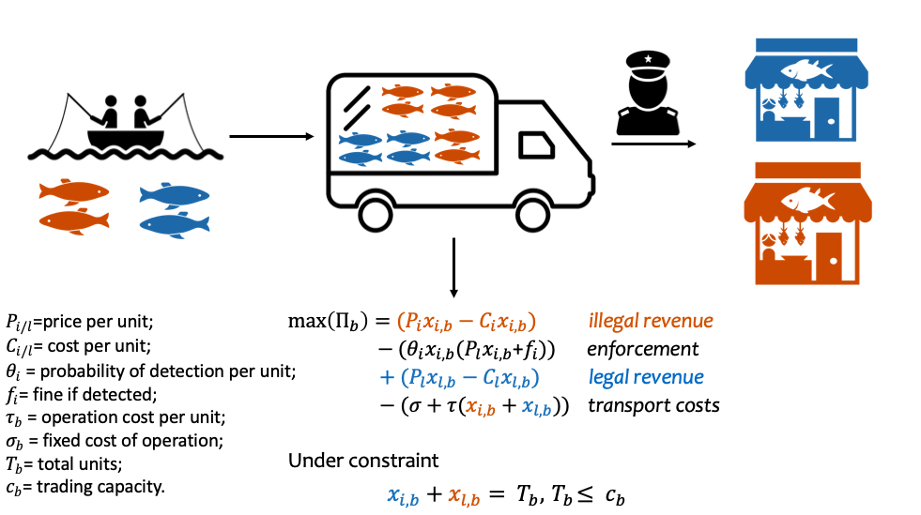

**Figure 1**. Schematic representation of the general, static form of the model.

Profit maximization problem is as follow:

$$Π= f\left(x_{i},x_{l}\right) (1)$$

Where:

$x_{i}$ = Illegal units $(i)$

$x_{l}$ = Legal units $(l)$

Then, for trader ($b$):

$\max\left(Π_{b}\right)={(P}_{i}x_{i,b}-C_{i}x_{i,b})-(θ_{i}x_{i,b}{(P}_{l}x_{i,b}\text{+}f_{i}))+{(P}_{l}x_{l,b}-C_{l}x_{l,b})-(σ+τ(x_{i,b}+x_{l,b}))$

Under constraint:

$$x_{i,b}+x_{l,b}= T_{b}, { T}_{b}≤ c_{b}$$

Where:

$P_{i/l}$ =price per unit; $C_{i/l}$ = cost per unit; $θ_{i}$ = probability of detection per unit; $f_{i}$ = fine if detected; $τ_{b}$ = operation cost per unit; $σ_{b}$ = fixed cost of operation; $T_{b}$ = total units; $c_{b}$ = trading capacity.

This can be solved analytically, given the condition:

${ x}_{l,b}= { T}_{b}-x_{i,b} (3)$ $0=P_{i} - C_{i}- θ_{i}P_{l}x_{i,b}-f_{i}θ_{i}$ $- P_{l} + C_{l}$

Which rearranges to

$$x_{i,b}=\frac{{(P}_{i} - C_{i}- f_{i}θ_{i} - P_{l} + C_{l})}{θ_{i}P_{l}} (4)$$

$C_{i/l}$ and $P_{i/l}$ are calculated as follow:

${{ C}_{i}=C}_{R}; {C_{l}=C}_{R}{+ V}_{l}$; $P_{i}=P_{R}$; $P_{l}=P_{R}{+ β}_{l}$ $(5)$

$C_{R}$ = reference cost per unit; $V_{l}$ = permit value per legal unit; $P_{R}$ = reference price per unit; $β_{l}$ = price premium per unit.

Then, from (4) and (5), $x_{i,b}$ is calculated by:

$${ x}_{i,b}=\frac{V_{l}-β_{l}- f_{i}θ_{i} }{θ_{i}(P_{R}{+ β}_{l} )} (6)$$

And the optimal strategic ratio of illegal units for trader (b), $R_{b}$, is calculated using (3):

$$R_{b}=\frac{x_{i,b}}{{(x}_{l,b}+x_{i,b})} (7)$$

1. **Dynamic Model**

For the dynamic model, cost and price parameter change in each time step, depending on amounts available at the supply level. Availability at each time step is taken from random draws from the distribution of availability calculated through Approximate Bayesian Computation (see section III):

$$n_{t}=rand(AvDist)$$

Then, $C_{i}$ and $C_{l}$ are:

$${C_{i,t}=C}_{R}\left(1-\frac{∈_{i}{(n}_{R}- n_{t})}{n_{R}}\right)$$

$${{ C}_{l,t}=C}_{R}\left(1-\frac{∈_{l}{(n}_{R}- n_{t})}{n_{R}}\right){+ V}_{l}$$

$n_{R}$ = reference quantity for reference cost; $∈_{i/l}$ = quantity elasticity of cost

And, $P_{i}$ and $P_{l}$ are:

$$P_{i,t}=P_{R}\left(1-\frac{∋_{i}{(n}_{R}- n_{t})}{n_{R}}\right)$$

$${ P}_{l,t}=P_{R}\left(1-\frac{∋_{l}{(n}_{R}- n_{t})}{n_{R}}\right){+ β}_{l}$$

$∋_{i/l}$ = quantity elasticity of price

Then, these cost and price parameter are used to calculate $x_{i,t,b} and x_{l,t,b}$, following (3) and (4), and total $x_{i} and x_{l}$ are calculated as follow:

$$x_{i}= \sum_{t=1}^{T}{\sum_{b}^{B}{x_{i,t,b}}}; x_{l}= \sum_{t=1}^{T}{\sum_{b}^{B}{x_{l,t,b}}}$$

$T$ = time horizon; B = traders in the system

And the overall ratio $R$ of legal to total units traded in the system is calculated by:

$$R=\frac{x_{i}}{{(x}_{l}+x_{i})}$$

1. **Using Approximate Bayesian Computation (ABC) for parameter and strategic ratios set estimation**
2. **Parameter Distribution Estimation (ABC Step 1)**

Usually, data on dual wildlife trading systems only encompass the legal sector. Then, the first step for running this model is to estimate unknown parameter distributions, which are related to illegal activity. An Approximate Bayesian Computation (ABC) rejection algorithm is used for this step (Beaumont, 2010). Here, values for unknown parameters are drawn from non-informative priors. Ranges for these non-informative priors can be obtained from key-informant interviews. Simulation runs using the general form of the model that do not match the pre-defined criteria are rejected. Conversely, parameter combination that meets the criteria are used for building the unknown parameters posterior distributions. The criteria for selection/rejection of the simulations is that total legal units traded ${(x}_{l})$ are within a pre-specified range (e.g. +/-10%) of official legal trading data.

1. **Ratios Set Distribution Estimation (ABC Step 2)**

After estimating the unknown parameter distributions, another ABC rejection algorithm is used to calculate the optimal set of strategic ratios for different stages within the time horizon. These various stages are defined by changes in intrinsic or extrinsic factors affecting trader’s maximization problem. For instance, there could be stages within the time horizon (such as a specific month), where enforcement is higher, or where the elasticity of the products is affected by external factors. Estimating a set of ratios within the time horizon allows for temporal variability to be accounted for in the trader's maximization problem. As such, it admits economic, social and ecological complexities. The number and length of stages, as well as the parameter that are affected in each of the stages, are set before running the model.

Similarly to (a), values for each of the ratios are drawn from non-informative priors. These priors range from 0 (no illegal units traded) to 1 (only illegal units traded). Model is run using its dynamic form, with values from the distribution of the unknown parameters (obtained in the previous step) and the corresponding parameter for each pre-defined stage. Simulation runs that do not match the pre-defined criteria are rejected. Conversely, the set of ratios that meet the criteria are used for building the set of strategic ratios posterior distributions. The criteria for selection/rejection of the simulations is the same than in (a): that total legal units traded ${(x}_{l})$ are within a pre-specified range of the official legal trading data. Moreover, only those sets of ratios within a pre-specified range of the highest profit in the posterior are selected.

1. **Case Study Application: Common-hake fishery**
2. **Background**

The common hake (*Merluccious gayi gayi*) is a fish species that plays a critical trophic role in the upwelling ecosystem off central Chile's coast (Neira & Arancibia, 2013; San Martín et al., 2013). The fishery that this species sustains is of great economic and social importance, directly employing around 3,000 small-scale fishers (SUBPESCA, 2016). Unreported fishing, where quota limits are exceeded, and fishers fail to report catches accordingly, is threatening the conservation of the stock and the livelihoods it supports (Plotnek *et al.*, 20; SUBPESCA, 2016). Anecdotal evidence, as well as enforcement records from the Chilean National Fisheries and Aquaculture Service (SERNAPESCA), indicate that this problem is particularly severe in the VII region of the country, where the majority of the catch is unreported (Oyanedel et al., 2020).

Fishers are the quota holders and by reporting, they entitle the trader with a legal permit for that catch which is discounted from the fishers’ quota. Because there are large amounts of underreported catch being landed, there is an active dual market of legal and illegal (unreported) products which lack permit. This market operates in a mixed fashion: legal and illegal products are traded in the same trucks and sold in the same markets. However, there is product and price differentiation: traders pay a "permit" for legal units (27-30 kgs. boxes) to fishers and, similarly, received a "price premium" at the market for those legal units.

1. **Data Sources**

We gathered primary data from government sources (SERNAPESCA). These data included legal units sold from fishers to traders per day for the 2015-2019 period. Moreover, we collected information on detectability rates and fines as well as price and cost data. This data helped build the survey (see below) and get a first understanding of the dimension of the parameters we were interested in.

Open-ended key-informant surveys were performed during March-April 2019. Due to COVID-19, all interviews were done over the phone or email to avoid close contact with participants. We used snowballing sampling, starting with leaders of the main fishers' associations in the region and known contacts of the researchers. We survey 23 informants, including fishers, government officials, fish traders, market operators, NGOs staff, and enforcement agents. Before each survey, we informed that participation was voluntary and that they could refuse to answer any particular question. The study complied with Oxford University's ethical requirements (approval number R68516/RE001).

The survey had two sections. The first had questions aimed at understanding trading dynamics and particulars about the day to day operation of the fishery. Here, we asked informants about the most critical factors affecting trading dynamics and the decision to trade legal or illegal units, as well as the relationship between fishers, traders and market operators. Responses in this section indicated the existence of different stages within a year, where some factors especially affected trading dynamics and the trader's decision to purchase legal or illegal products. From the survey’s responses, we categorized these stages as:

1. *Eastern month*: due to an increase in demand before and during eastern, price elasticity diminished. Moreover, enforcement increases during this period, which lasts for a month.
2. *Pre/post ban*: there is an increase in demand before the September ban (to ensure frozen supply during the ban) and after the ban because of lack of availability. These increases in demand are reflected in lower elasticity at the market.
3. *End of year*: because the quota is not transferable across years, fishers who still have quota permits by the last weeks of the year rush to sell it, lowering the permit value.
4. *Primary strategy*: this is the strategy used across the year, where parameters values are within normal ranges

The second section of the survey assessed parameter values that were not available from government data. For some of the parameters evaluated in this section, responses were consistent, and therefore those values were used directly in the model (e.g. permit value, number and capacity of trucks). For parameters where answers were scattered or where we could not get valid information, we used survey responses to set the ranges for the unknown parameters priors to be used in ABC Step 1. These parameters were: price premium, detectability and overall landings.

1. **Results**:
2. **Parameter Estimation (ABC Step 1)**

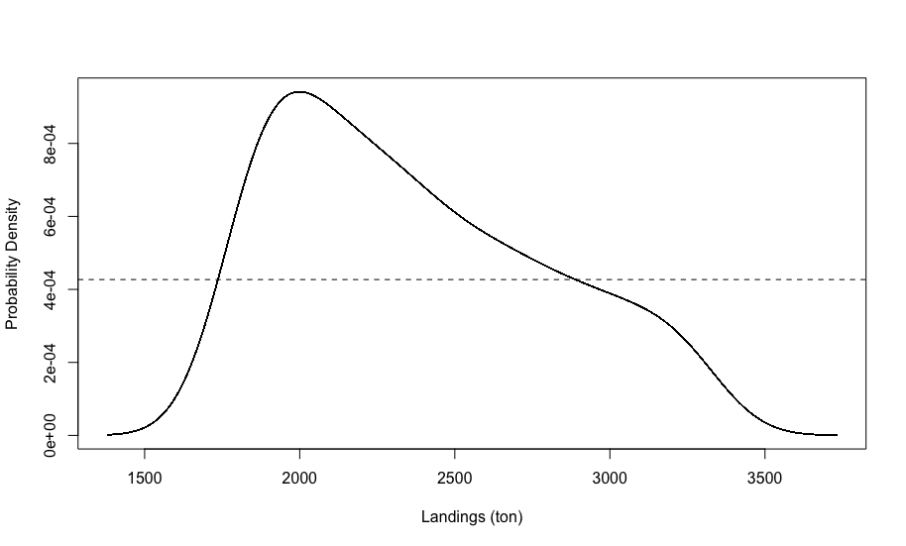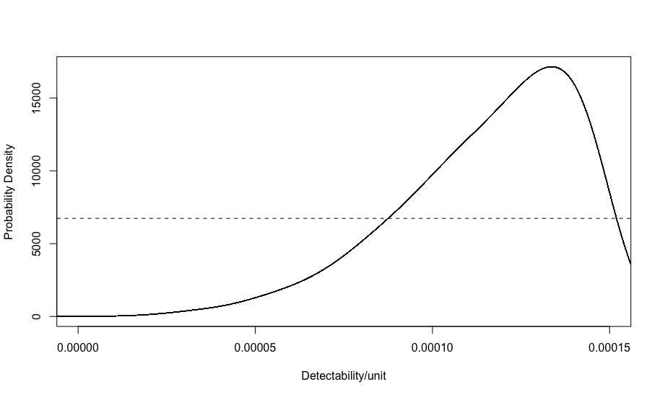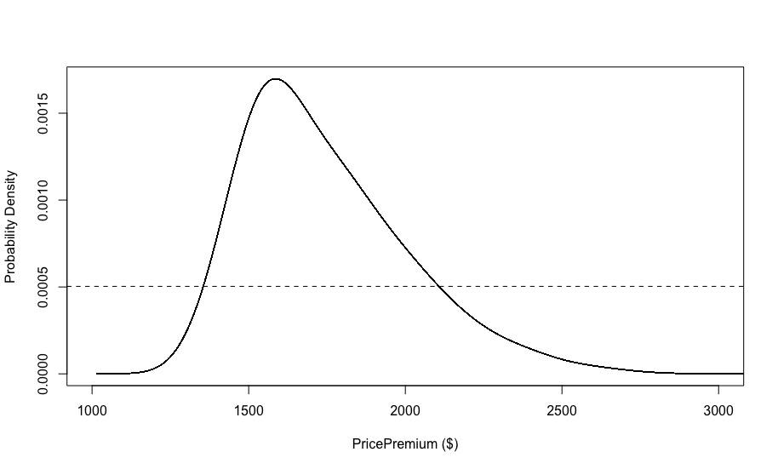

**Figure 2**. Prior (dotted) and posterior (line) probability distribution for landings (a), detectability (b) and price premium (c) parameters.

1. **Set of Strategies (ABC Step 2)**

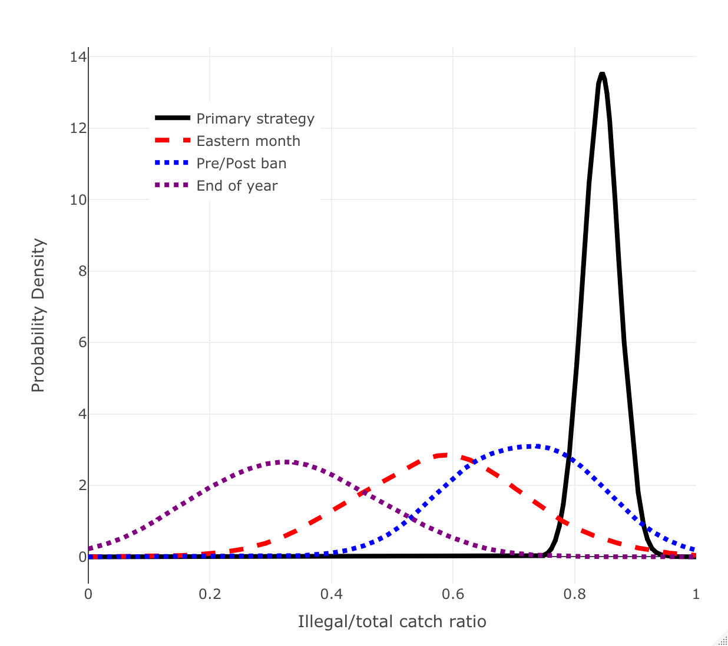

**Figure 3**. Probability distributions of the set of illegal/total catch ratio strategies in each stage.

1. **Simulation against landings data comparison**

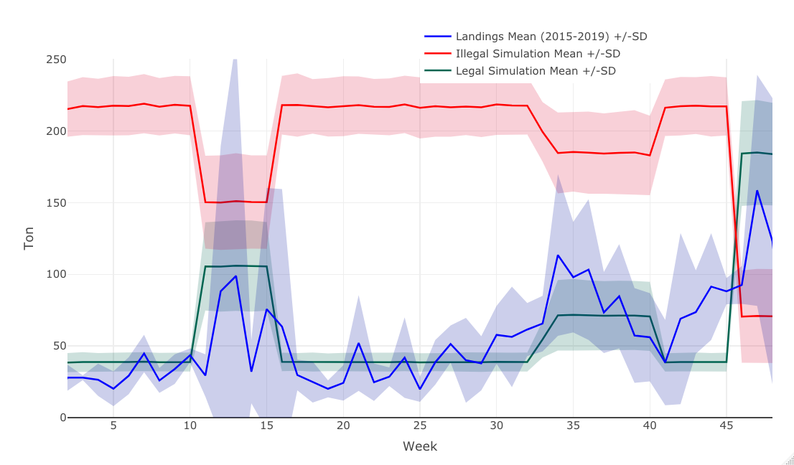

**Figure 4**. Simulated results (green for legal, red for illegal) per week, and landings data for the 2015-2019 period (blue), over a one-year time horizon.

1. **Parameter Sensitivity Analysis**

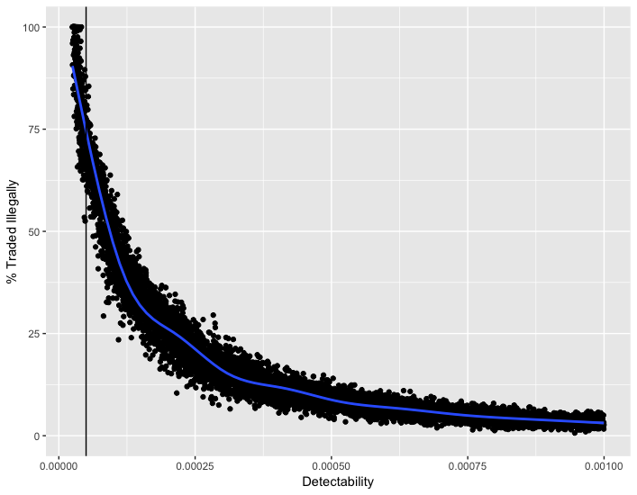

**Figure 5**. Sensitivity analysis for detectability parameter.

1. **Scenario Simulations**